Kyle’s Little Book of Field Study: Site Introduction

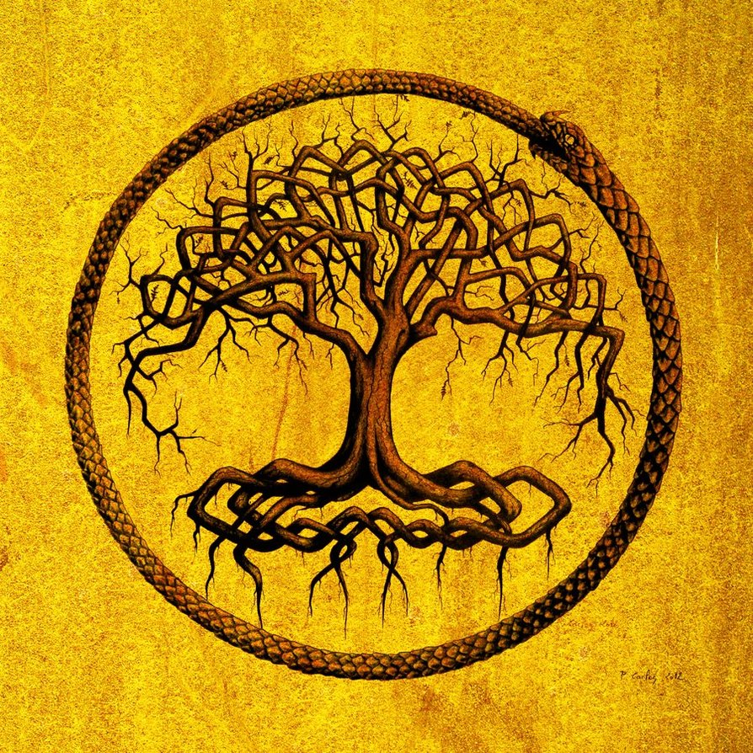
By Kyle Rockwell 2/3° Paula rockwell (415)-897-6179

Objective: To observe the changes of a specific site over 8 weeks.
Site Description: partial sun, tree provides much shade. No animals were seen, but some deer droppings were on the ground. The sounds of birds chirping and no distinct smells
Prediction: I predict that that the day and evening temperature will increase and the length of the day will be longer.

Measurement | Intro | Week 2 | Week 3 | Week 4 | Week 5 | week 6
Plant 1 height | 100 ft | 100ft | 100ft | 100ft | 100ft | 100.1ft
Plant 2 height | 60 ft | 60ft | 60ft | 60ft | 60ft | 60ft
% of Poison oak covering area | %3 | %3 | %2 | %2 | %1.5 | 1%
Flying insects seen | ~6 | ~7 | 0 | 0 | 1 | 0
Deer footprints/ droppings | 1 | 0 | 2 | 0 | 0 | 1
Avg day Temp | 70 F | 70F | 65F | 60F | 65F | 70F
Avg evening temp | 60 F | 65f | 65F | 60F | 60F | 65F
avg rainfall | 0 in | 0 in | 1/10 in | 0 in | 0 in | 0in
day length | 14 HRs | 14:02 | 14:15 | 14:20 | 14:22 | 14:24

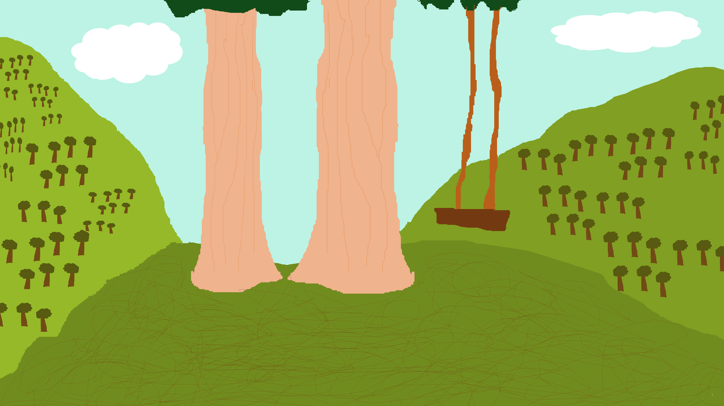
Map of Area Drawn by Kyle Rockwell

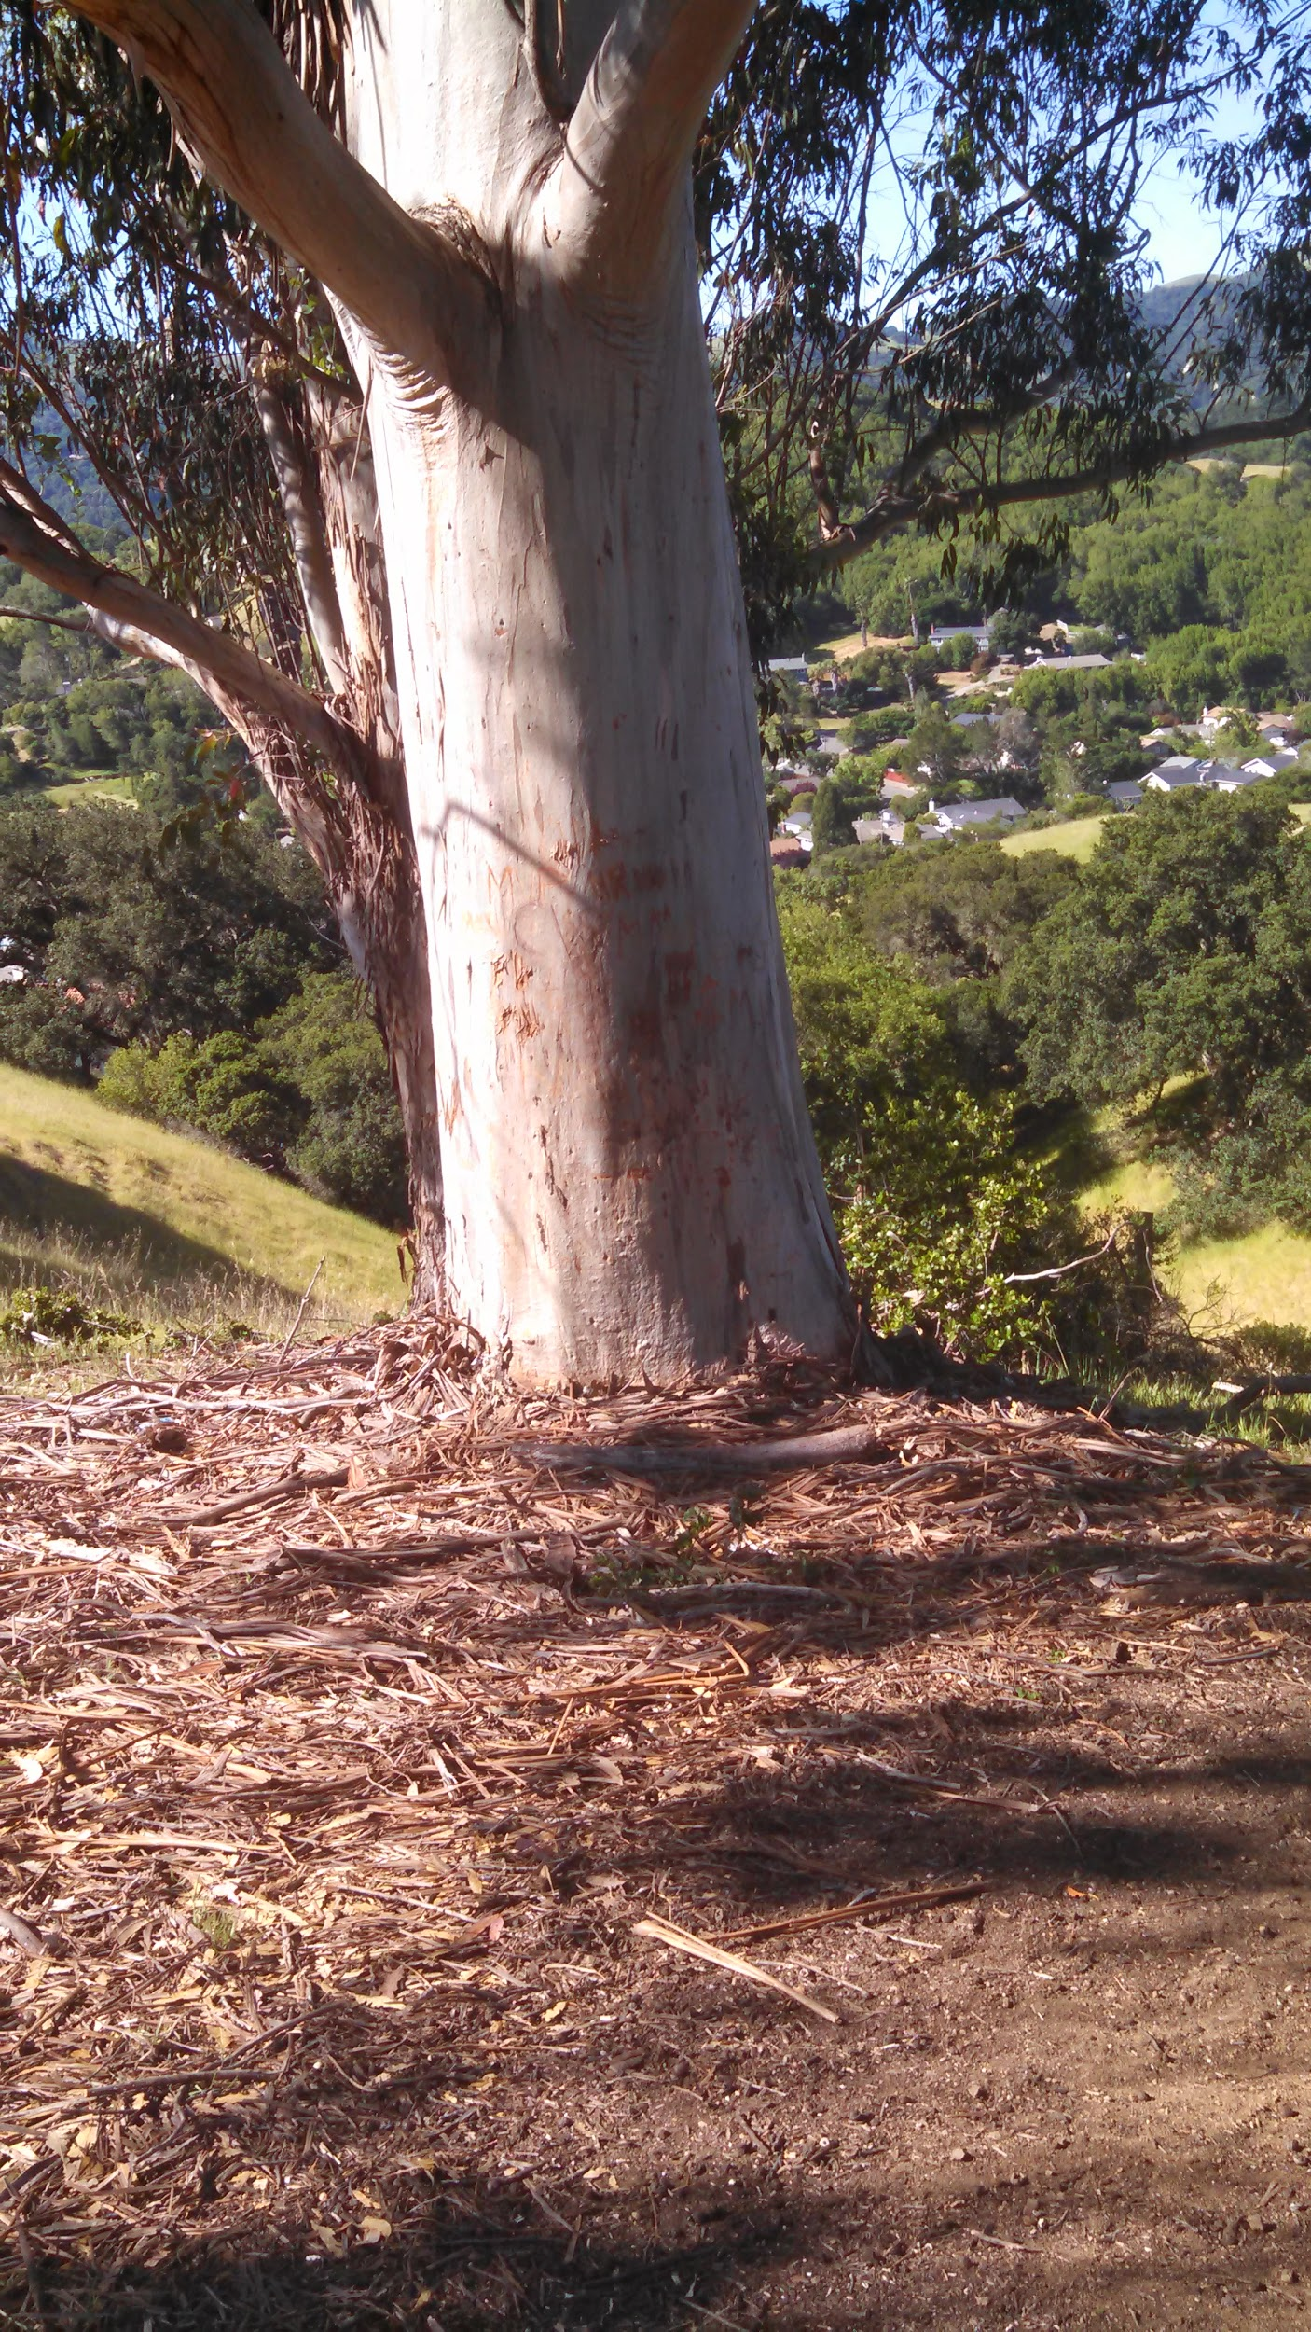
Picture of area

Focus questions
Wk1
- Temperate woodland and shrubland, it fits the description
- There are birds in trees, and bugs in the grass
- Bugs eat grass, and birds eat bugs
Wk2
- There is a rope swing, trash on the ground and carvings in the large tree
- The ground is dry, there are rocks on the ground, and not many plants to eat
Wk3
- The bacteria helps fixate nitrogen which is important for plants and animals
- They are found in the ground, and they decompose
- No
Wk4
- The only invertebrates I saw were worms, and they were decomposers
- They live in the dirt
Wk5
1. PLant 1 Dicot could tell by leaves
2. plant 2 dicot could tell by leaves
3. plant 3 dicot could tell by leaves
4 plant 4 dicot could tell by leaves
5. plant 5 monocot it was grass
wk6
- Dermal, vascular, and ground tissue all have different function. vascular is for moving nutrients ground tissue is for storing nutrients, and dermal tissue is for protection
- the nutrients are potassium nitrogen correct acidity and phosphorus
- the different adaptations are poison oak causing rashes, the eucalyptus dropping nuts, and the oak leave being
- birds pollinate, and bees and butterflies, can tell by how the flowers were.

